- Project Background:
Financial Institutions process large volume of credit card applications daily. A significant number of applications are routed to manual review queues, due to borderline credit scores, incomplete documentation, fraud checks, or policy expectations. These manual reviews increase processing delays, operational costs, and customer dissatisfaction.
Simply, with the help of this we can identify how many credit cards cases move straight through automatically, and how many get routed to manual review because of error, risk flags, missing data, disputes or compliance check. The goal is to reduce manual handling, shorten resolution time, and give operations teams one place to monitor backlog, aging, and service levels.
Business Context: Over the last 4 years, U.S. banks and financial institutions have focused heavily on automating payment and card workflows, especially in dispute handling, exception management, and card processing optimization. The reason is simple: manual queues create delays, higher operating costs, and inconsistent customer experience, while automation improves speed and control. Many institutions have moved toward centralized dashboards so teams can see open cases, root causes, and SLA risk in real time.
STP (Straight Through Processing): Straight-through processing means the case or transaction can be processed end to end without manual intervention. In a credit card context, that may include application validation, dispute intake, transaction review, payment handling, or exception routing depending on the process you model. If something fails a rule, it moves into an exception queue for manual review.

Why exception queues matter
Exception queues are where the operational pain usually happens. They collect items with missing fields, mismatched records, fraud indicators, compliance concerns, or unusual transaction patterns, and those items need review before completion. Banks use exception management tools and dashboards to assign ownership, track aging, send alerts, and keep unresolved items from sitting too long. This is why an optimization dashboard is valuable: it helps leaders see where work is piling up and what is causing the bottleneck.

What banks have been doing
Recent market activity shows banks and issuers investing in dispute automation, centralized case management, and payment-processing efficiency tools. These tools are designed to reduce manual effort, improve compliance, and create better customer service experience. Even vendors targeting financial institutions now emphasize real-time dashboards, exception alerts, and workflow automation as core features.

- Problem Statement:
The bank lacks centralized visibility into STP rates, exception queue aging, approval bottlenecks, and customer risk trends. Operations team struggle to identify processing inefficiencies and prioritize high risk applications effectively.
“Credit card operations at banks generate a large number of exceptions that require manual review, but limited visibility into queue status, root causes, and aging prevents teams from optimizing straight-through processing and meeting service-level targets.”

Banks and financial institutions handling credit card operations often face a high volume of transactions, applications, disputes, and exceptions that do not process automatically and must be reviewed manually. This creates queue backlogs, longer turnaround times, SLA breaches, inconsistent customer experience, and higher operational costs.

The problem is that operations teams often lack a single dashboard that shows which cases are flowing through straight-through processing, which items are stuck in exception queues, why they are stuck, and how long they have been aging. Without this visibility, it becomes difficult to prioritize work, reduce manual effort, and improve resolution speed.
- Project Objectives:
To design an analytics dashboard that monitor application processing efficiency, manual review trends, approval outcomes, and customer risk indicators to support operational optimization and decision making.

Specific objectives

- Measure the straight-through processing rate for credit card cases and identify where manual intervention occurs most often.
- Track exception queue volume, aging, and resolution time to highlight operational bottlenecks.
- Classify exceptions by reason code so recurring issues can be identified and reduced.
- Improve SLA compliance by flagging high-risk or overdue items for quicker action.
- Provide management with a single dashboard for backlog, team performance, and workflow health.
- Support process automation recommendations by showing which exceptions are most suitable for straight-through handling.

- Scope:
This will explain what part the dashboard will cover and what will not be covered.
IN SCOPE:
- Credit Card Case Intake & routing.
- STP rate tracking.
- Exception queue monitoring by reason code, age & priority.
- SLA tracking and overdue case alerts.
- Manual review workload and backlog trends.
- Root cause analysis of recurring exception types.
- Dashboard KPIs for operation managers and analyst.
OUT SCOPE
- Real time application processing.
- Machine learning risk prediction.
- Fraud detection automation.
- Live banking system integration.
- Core card network authorization logic.
- Customer facing mobile app features.

- Key Performance Indicators:

KPI | Formula | Meaning
Total Applications | Count of all applications received | Measures overall volume.
Approval Rate % | Approved Applications / Total Applications x 100 | Shows how many applications are approved.
STP Rate % | Straight-Through Processed Applications / Total Applications x 100 | Measures automation efficiency.
Manual Review Rate % | Applications Sent to Manual Review / Total Applications x 100 | Shows how often exceptions occur.
Avg Processing Time | Total Processing Time / Total Applications | Measures how long cases take on average.
SLA Breach % | Cases Exceeding SLA / Total Cases x 100 | Shows service delay risk.
Default Rate % | Defaulted Accounts / Total Approved Accounts x 100 | Measures credit risk after approval.
Avg Credit Score | Sum of Applicant Credit Scores / Total Applicants | Shows the average risk profile.
- Volume KPIs: Total Applications
- Operational KPIs: Approval rate, STP rate, Manual Review Rate, Avg Processing Time.
- Risk KPIs: SLA Breach, Default rate, Avg Credit Score.

- Dataset Structure:
Done in Excel.

- Business Features

Features | Description
Application Processing Performance Monitoring | Provides visibility into daily application processing trends to monitor workload and processing efficiency. This feature will cover: Total application received, Approval/rejection trends, Daily/weekly/monthly volume analysis
STP Efficiency Tracking | Provides information on how many applications are automatically processed without manual intervention. This feature will have: STP rate%, Auto approved/rejected applications, STP trend analysis.
Exception queue monitoring & Aging Analysis | Provides visibility into applications routed to manual review queues and aging delays. This feature covers: Manual review volume, Queue aging buckets, Pending application analysis, SLA breach monitoring.
Customer Risk Segmentation | Provides visibility into applicant risk patterns to support better credit decisioning. This feature covers: Credit score segmentation, high risk customer identification, DTI analysis, Default trend analysis.
Processing Bottleneck Identification | Identifying operational bottlenecks that are causing approval delays. This feature covers: Avg Processing days, Delayed applications, Stage-level delay analysis, Queue congestion trends.
Operational KPI Dashboard & Executive Reporting | Provides centralized operational reporting for monitoring applications performance and risk trends. This feature covers: Executive KPI Dashboard, Trend Visualization, Interactive filtering, Operational summary metrics.

#Why are applications routed to manual review?
- Credit score between 650-720
- High requested limit
- Missing documentation
- High DTI ratio
#What causes SLA breach?
- High queue backlog
- Limited underwriters
- Incomplete applications

- User Stories

Feature 1: Application Processing Performance Monitoring
User Story 1 (US-01): View Daily Application Volume
As an Operations Manager, I want to view the total number of credit card applications received each day, so that I can monitor workload trends and plan staffing accordingly.
Business Rule:
Total Applications count must include all records received on the selected date regardless of approval status, channel, or product type.

Acceptance Criteria:
- Dashboard displays total applications count for the current day, updated on each refresh.
- Volume can be filtered by daily, weekly, and monthly time periods.
- A trendline chart shows volume over the selected time period.
- Data can be filtered by product type and channel (online, branch, phone).
US-02: Track Approval and Rejection Trends
As a Credit Analyst, I want to see approval and rejection trends over time, so that I can identify shifts in underwriting performance and flag anomalies early.
Business Rule:
Approval status must only contain approved, rejected, or pending. Any other value is invalid and excluded from rate calculations.
Acceptance Criteria:
- Dashboard shows Approval rate% and Rejection rate% as KPI tiles.
- A chart visualizes approval vs rejection counts across the selected time period.
- Results can be segmented by product type (Standard, Premium, Secured)

Feature 2: STP Efficiency Tracking
US-03: Monitor Overall STP Rate
As an Operations Manager, I want to see the percentage of applications processed without manual intervention, so that I can measure automation efficiency and track improvements over time.
Business Rule:
An application can only be marked STP_Flag = Yes if Manual_Review_Flag = No. Both flags cannot be Yes simultaneously.
Acceptance Criteria:
- STP rate % KPI tile is visible on the main dashboard.
- STP trend chart shows rate changes over time (daily/weekly/monthly).
- Count of auto approved and auto rejected application is displayed separately.
- STP data is filterable by product type and application channel.
US-04: Identify Non-STP Applications Routed to Manual Review
As a Process Improvement Analyst, I want to see which categories of applications most frequently fail STP, so that I can recommend rule changes or automation enhancements to reduce manual handling.
Business Rule:
An application is routed to manual review if any one of the following conditions is met: Credit_Score is between 650–720, DTI_Ratio > 43%, Requested_CR_Limit > $25,000, or Exception_Reason = Missing Documentation.
Acceptance Criteria:
- Non-STP applications are broken down by exception reason code (borderline credit score, high DTI, missing documentation, high requested limit).
- A ranked bar chart shows top exception reasons by frequency.
- Manual Review Rate % is shown alongside STP Rate% for direct comparison.

Feature 3: Exception Queue Monitoring & Aging Analysis
US-05: Monitor Exception Queue Volume by Reason Code
As an Operations Manager, I want to see how many applications are currently in the exception queue and why, so that I can direct my team’s attention to the most common impactful issues.

Business Rule:
An application is counted as "in queue" only when both Manual_Review_Flag = Yes AND Approval_Status = Pending are true simultaneously.
Acceptance Criteria:
- Total counts of applications currently in the exception queue is displayed as a KPI tile.
- Queue is broken down by “Exception_reason_field” showing count per reason code.
- A pie or stacked bar chart shows exception reason distribution.
- Queue volume can be filtered by date range and product type.
US-06: Analyze Queue Aging and Overdue Cases
As an Operations Supervisor, I want to see how long applications have been sitting in the exception queue, so that I can prioritize the oldest cases and prevent SLA breaches before they occur.
Business Rule:
SLA_Breached must be set to Yes whenever Processing_Time exceeds SLA_Target_Minutes, and any application aged 7+ days is automatically escalated to Critical priority regardless of SLA status.
Acceptance Criteria:
- Queue aging is bucketed into: 0-1 day, 2-3 days, 4-7 days, and 7+ days.
- A stacked bar or heatmap chart shows aging bucket distribution across exception reason codes.
- Cases breaching SLA are highlighted in red and surfaced in an “Overdue Cases” alert panel.
Feature 4: Customer Risk Segmentation
US-07: Segment Applicants by Credit Score Range
As a Credit Risk Analyst, I want to view the distribution of applicants across credit score bands, so that I can understand the risk composition of incoming application portfolio.
Business Rule:
Credit_Score must be a numeric value between 300 and 850 and segmented into five standard U.S. bands: Poor (below 580), Fair (580–649), Good (650–719), Very Good (720–779), and Exceptional (780+).
Acceptance Criteria:
- Applicants are grouped into bands. Below 580 (poor), 580-649 (fair), 650-719 (Good), 720-779 (Very Good), 780+ (exceptional).
- A histogram or donut chart shows the count and percentage of applicants in each band.
- Avg Credit Score KPI tile is displayed and refreshes with active filters.
- The 650-720 band is visually flagged as the “Manual Review Trigger Zone” to align with the routing logic.
US-08: Analyze DTI Ratio and Default Risk
As a Credit Risk Manager, I want to analyze the relationship between DTI ratio and default outcomes, so that I can validate whether high DTI applicants represent a disproportionate share of defaults.
Business Rule:
Default_Flag = Yes can only be assigned to applications where Approval_Status = Approved — rejected or pending applications cannot be marked as defaulted.
Acceptance Criteria:
- DTI ratio is grouped into bands: Below 20%, 20-35%, 36-50%, and Above 50%.
- Default rate% is calculated per DTI band and shown in a comparative bar chart.
- Overall Default rate% KPI tile is present.
- High risk applicants (DTI above 50% or credit score below 580) are flagged in an alert list for underwriter review.
Feature 5: Processing Bottleneck Identification
US-09: Track Average Processing Time and Delayed Applications:
As an Operations Manager, I want to see the average time it takes to process an application from submission to decision, so that I can identify where delays are accumulating and take corrective actions.
Business Rule:
An application is flagged as Delayed when its Processing_Time exceeds 2x the current average processing time across all applications.

Acceptance Criteria:
- Avg processing time KPI tile is displayed in minutes, derived from processing time field.
- Avg processing time is shown separately for STP vs Manually reviewed applications to highlight the gap.
- Applications exceeding 2x the average processing time are flagged as “Delayed” and counted separately.
- Processing time trend is shown over time to reveal patterns such as end-of-month volume surges.
US-10: Identify Queue Congestion by Exception Type
As a Process Improvement Analyst, I want to see which exception types are contributing the most to the queue congestion, so that I can prioritize process fixes or automation investments for the highest-impact areas.
Business Rule:
An exception type is classified as a critical bottleneck only when it ranks in the top 2 by open case volume AND its average queue age exceeds 4 days — both conditions must be true.
Acceptance Criteria:
- A congestion table shows each exception type with its open case count, average age, and SLA breach count side by side.
- Exception types with both high volume and high average age are flagged as critical bottlenecks.
- Data can be filtered by time period and product type.
Feature 6: Operational KPI Dashboard & Executive Reporting
US-11: Access a Centralized Executive KPI Dashboard
As a VP of Credit Card Operations, I want a single page dashboard showing all critical KPI’s at a glance, so that I can assess the health of operations in real time without navigating multiple reports.
Business Rule:
All 8 KPIs must use only the formulas defined in the BRD KPI section, with color thresholds applied as: STP Rate % green ≥ 80%, SLA Breach % red > 10%, Default Rate % red > 5%, and Manual Review Rate % red > 35%.

Acceptance Criteria:
- All 8 KPI’s from BRD are present as tiles.
- KPI tiles use color coding: green for on-target, amber for near threshold, red for breached.
- Dashboard renders correctly at a minimum width of 1280px.
- All KPI value update when global date range or product type filters are changed.

US-12: Use Interactive Filters for Drill-Down Analysis
As a Data Analyst, I want to filter the dashboard by date range, product type, and channel, so that I can investigate specific segments or time periods without building separate reports.
Business Rules:
When multiple filters are applied simultaneously, all conditions must use AND logic, and when no data matches the filter combination, all visuals must display "No Data Available" instead of a blank or broken chart.
Acceptance Criteria:
- Global Filter panel includes: Date range (date picker), Product Type(multi-select), and channel (multi-select).
- All charts KPI tiles, and tables respond to filter changes without a page reload.
- A “reset filters” button restores all filters to their default state.
- When no data matches the selected filters, visuals display a “No data available” message rather than an error.

- AS-IS Process:
The STP path (left, green) is the clean path — the application passes all automated rules, gets auto-approved or rejected with no human involved, and the applicant is notified. This is what the bank wants more of.
The Exception path (right, orange/red) is where the operational pain lives — the application fails a rule, gets an exception reason code assigned, sits in the manual review queue, an underwriter picks it up, the SLA clock is ticking the entire time, and if the underwriter takes too long the SLA is breached.

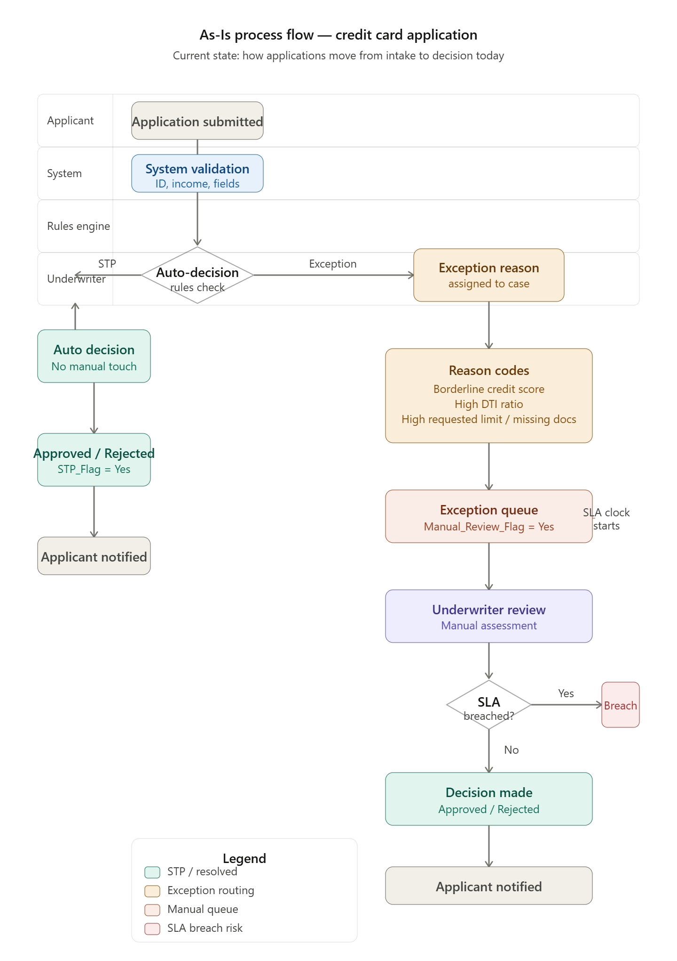

TO-BE Process:
Lane 2 — System
The system immediately performs automated data validation — it checks that all required fields are filled, the applicant's identity can be verified, and income information is present. This happens in seconds with no human involvement. If validation fails, the application is returned to the applicant for correction before it even enters the rules engine. This is a small but important improvement — in the As-Is, incomplete applications were sometimes making it further into the process before being caught, which wasted underwriter time.

Lane 3 — Rules Engine
The rules engine evaluates every application against the four business rules defined in your BRD:
- Is the credit score between 650 and 720?
- Is the DTI ratio above 43%?
- Is the requested credit limit above $25,000?
- Is there missing documentation?
If none of these conditions are triggered — the application goes left on the diagram, gets auto-approved or auto-rejected with STP_Flag = Yes, and the applicant is notified immediately. This is the clean, fast path that costs the bank nothing in manual effort.
If any one condition is triggered — the application goes right, gets an exception reason code assigned, and enters the exception queue. This is where the To-Be process makes the biggest improvements over the As-Is.
Lane 4 — Exception Queue
In the As-Is, the exception queue was essentially a black box. Cases went in, and underwriters picked them up whenever they could.
In the To-Be, three things happen automatically the moment a case enters the queue:
Queue entry is logged with a timestamp and the SLA clock starts immediately. The system knows exactly when this case needs to be resolved by.
An aging bucket is assigned — the case is immediately categorized as Fresh (0–1 day), Aging (2–3 days), At Risk (4–7 days), or Critical (7+ days). This bucket is not static — it updates every day the case remains unresolved.
Smart priority routing assigns a priority level — Critical, High, Medium, or Normal — based on the combination of aging bucket and risk flags. A high-DTI applicant with a credit score below 580 who has been in the queue for 5 days gets a different priority than a borderline credit score case that arrived this morning. This is the key operational improvement.
Lane 5 — Dashboard (The New Lane — Core of Project)
This lane did not exist in the As-Is. This is what entire project is building.
The dashboard monitors every single case in the exception queue in real time. It is continuously calculating all 8 KPIs from your BRD — STP rate, manual review rate, SLA breach percentage, average processing time, and so on.
At the center of this lane is the SLA at risk decision point. The dashboard is constantly asking: is any case approaching or past its SLA target?
If Yes — a red alert is immediately sent to the Operations Manager. The case is automatically escalated to the top of the queue so the next available underwriter picks it up first. This is proactive — the breach is prevented before it happens, not recorded after.
If No — the case flows normally. It is packaged with full context — the applicant's risk profile, exception reason code, time remaining on SLA, and aging bucket — and sent to the underwriter queue. This is a significant improvement over the As-Is where underwriters had to manually pull this information from different systems.
Lane 6 — Underwriter
In the To-Be, the underwriter receives cases that are already fully contextualized. They can see at a glance:
- Why this application was flagged
- How long it has been waiting
- How much SLA time remains
- Whether it has been escalated as critical
This means the underwriter spends less time gathering information and more time making the actual credit decision.
After reviewing the case they make one of two decisions — Approved or Rejected. Either way, the outcome is immediately recorded with a timestamp so Processing_Time is calculated accurately and SLA_Breached is determined.
Both outcomes feed back into the dashboard update at the bottom — the KPIs are recalculated, the case is closed, and the queue count drops by one. The applicant is then notified of the decision.
From this, it will help in improving:
Visibility: Operations now has a single dashboard showing every case, its age, its reason code, and its SLA status.
Proactive SLA management: Breaches are flagged before they happen, not after. This directly reduces the SLA Breach% KPI.
Smarter workload allocation: Underwriters work the most critical cases first instead of oldest cases first. This reduces average processing time and improves customer experience.

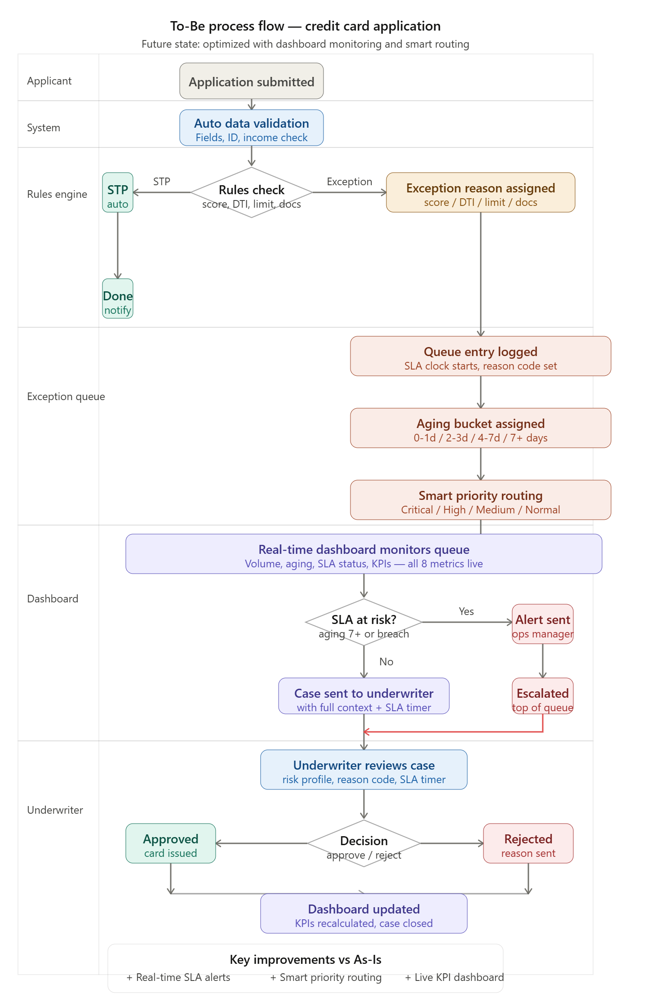
- Data Creation & EDA analysis
Done in Excel
- Dashboard Wireframe
A dashboard wireframe is a visual blueprint of your dashboard. It is usually drawn before we build anything in any visualization tool. For us its POWER BI.
It shows:
- Where each chart will sit on the page
- What type of chart goes in each position
- Where the KPI tiles will be placed
- Where the filters and navigation will go
It does not need to be perfectly designed or have real data in it. It is just a sketch that answers the question — "what will this dashboard look like before I spend hours building it?"
Our project will include 3 page dashboard wireframe.
Page 1 — Executive Overview is what the VP of Operations sees first. All 8 KPI tiles with green, amber, red color coding at the top so the health of the entire operation is visible in 5 seconds. Two trend charts below show volume and approval trends over the year. Three smaller charts at the bottom give a quick product-level breakdown.
Page 2 — Operations Dashboard is the working page for the Operations Manager. It starts with the 4 operational KPIs, then breaks down STP vs manual by channel, exception reasons ranked by frequency, queue aging buckets in a heatmap style, the monthly SLA breach trend line, and the bottleneck table that maps directly to US-10.
Page 3 — Risk Dashboard is for the Credit Risk Analyst. Risk KPIs at the top, credit score band distribution with the manual review trigger zone highlighted, the credit score vs approval rate scatter, DTI distribution, default rate by DTI band, and the high risk vs standard applicant donut chart.
Every filter bar is identical across all three pages — Date Range, Product Type, and Channel — so filters apply globally across the whole dashboard.

